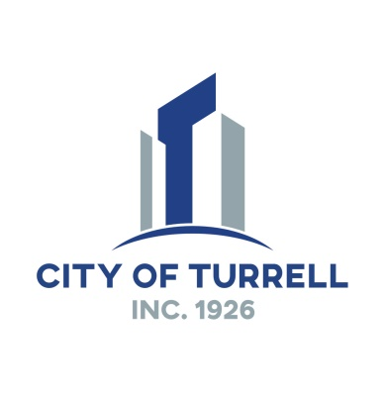

**MAYOR**

Charles Webster

**CLERK/TREASURER**

Dora Jordan

**CITY RECORDER**

Brandy Beaulieu

**CITY ATTORNEY**

Curtis Walker

**CITY COUNCIL**

Emanuel Harris

Angela Scott

James Lowery

Cassius Moore

Antonio Greer

Jeffery Thomas

**Turrell Court Schedule 2021 – 2022**

**August 10, 2021**

**September 14, 2021**

**October 12, 2021**

**November 09, 2021**

**December 14, 2021**

***Court Dates For 2022***

**January 11, 2022**

**February 08, 2022**

**March 2022 – No Court**

**April 12, 2022**

**May 10, 2022**

**June 14, 2022**

**July 12, 2022**

**August 09, 2022**

**September 13, 2022**

**October 11, 2022**

**November 08, 2022**

**December 13, 2022**

**Any changes to this schedule will be posted – All court times are at 2:00 pm unless otherwise advised.**

*www.cityofturrell.com*